LYCOS SCHOOL



A PROJECT OF SCHOOL MANAGEMENT

**INDEX**

ABSTRACT -------------> 4

SOFTWARE’S REQUIRED ----------->5

HTML5 (Hyper Text Markup Language) ------->6

CSS (Cascading Style Sheet) --------------> 7 -11

MySQL -----------------------> 12- 13

BOOTSTRAP ----------------------> 14-15

PYTHON ------------------------> 16

DJANGO -----------------> 17 -23

JAVASCRIPT ----------------> 24

CONCLUSION ------------->26

**TEAM MEMBERS**

1. SAIJYOTHI

2. GEETHANJALI

3. MAMATHA

4. SANDEEP G

5. YASHWANTH P

6. KRISHNAM RAJU

7. SOUMYARANJAN

**ABSTRACT**

Lycos School is an online school management website to manage the details and performance of Student and Teacher. It contains all the details and performance about students and teacher. From the login page, When principal login and access to view all the data of student and teacher. And the Superintendent have access to view all data of students and teacher details. The clerk has access to enter all data and view only student data.

**Software’s Required**

|  |  |
| --- | --- |
| SOFTWARE NAME | VERSION |
| HTML(Hyper Text Markup language) | HTML 5 |
| CSS (cascading style sheet) | CSS 3 |
| Bootstrap | Bootstrap 4 |
| MySQL | 8.0.32 |
| Python | Python 3.11 |
| DJango | 4.1,4.1.6 |
| JavaScript | Es6 |
| Operating system | Windows 10/11 |

**HTML**:

HTML stands for Hyper Text Markup Language. It is used to design webpages using a markup language. Hypertext defines the link between webpages.

HTML is a markup language used by the browser to manipulate text, images, and other content, in order to display it in the required format. .

HTML5 is the fifth revision of the HTML standard and brings a range of new features and capabilities to web development. Some of the most notable features include improved support for multimedia content, such as video and audio, new semantic elements to describe different parts of a web page, and improved support for offline web applications.

**CSS:**

**C**ascading **S**tyle **S**heets, fondly referred to as **CSS**, is a simply designed language intended to simplify the process of making web pages presentable. CSS allows you to apply styles to web pages. More importantly, CSS enables you to do this independent of the HTML that makes up each web page. It describes how a webpage should look: it prescribes colors, fonts, spacing, and much more. In short, you can make your website look however you want. CSS lets developers and designers define how it behaves, including how elements are positioned in the browser

CSS3, on the other hand, is the latest version of the style sheet language used to describe the look and formatting of a web page. Some of the most notable features in CSS3 include support for responsive design, new layout and positioning techniques, and advanced effects and animations.

Together, HTML5 and CSS3 provide a powerful platform for creating modern, dynamic, and engaging websites and web applications.

By using Html5& Css3 we have developed following web pages.

* Login.html
* Student Information.html
* Student Performance.html
* Teacher Information.html
* Teacher Performance.html

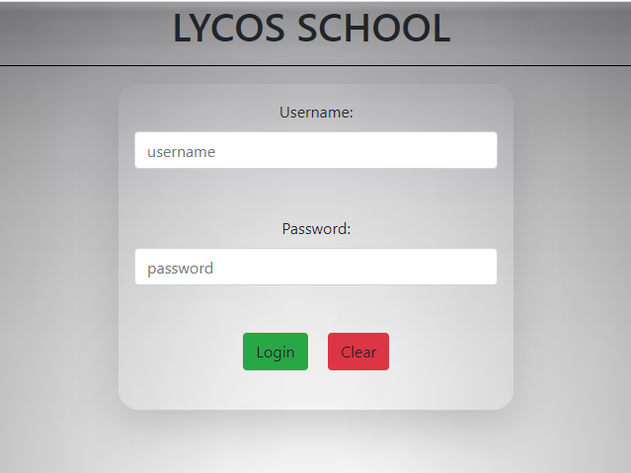

**[Login Page]**

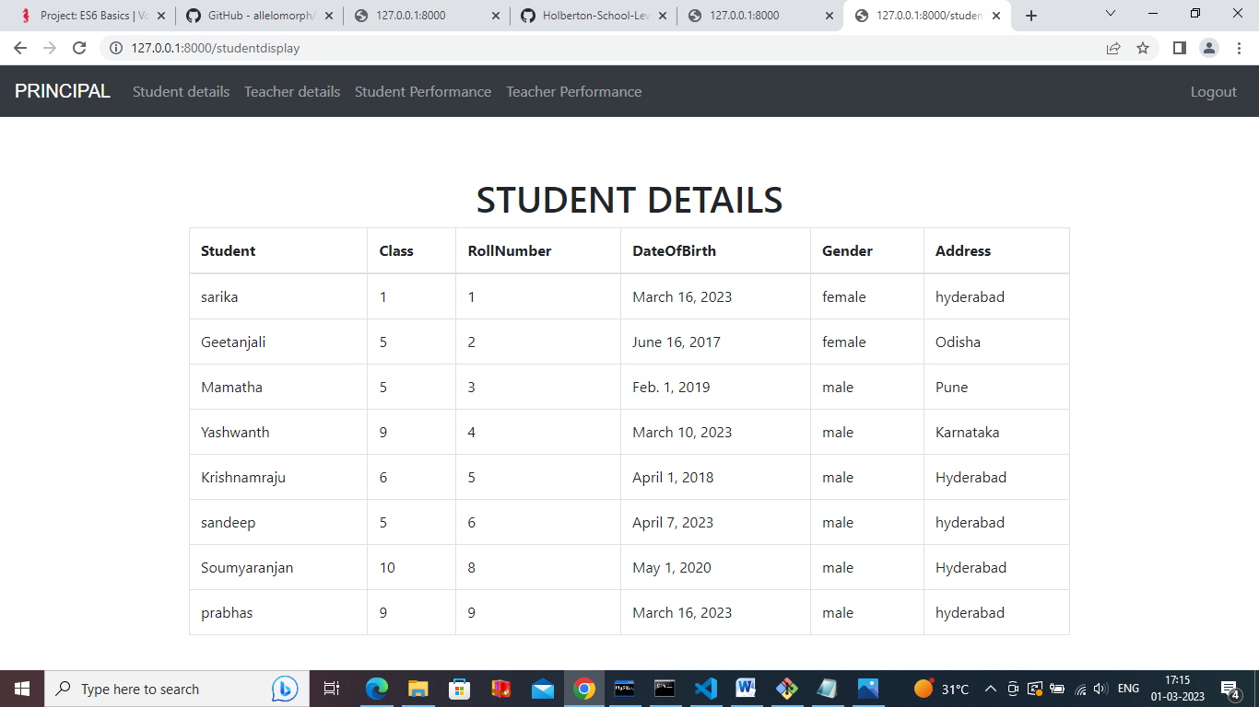

**[Principal Login Form]**

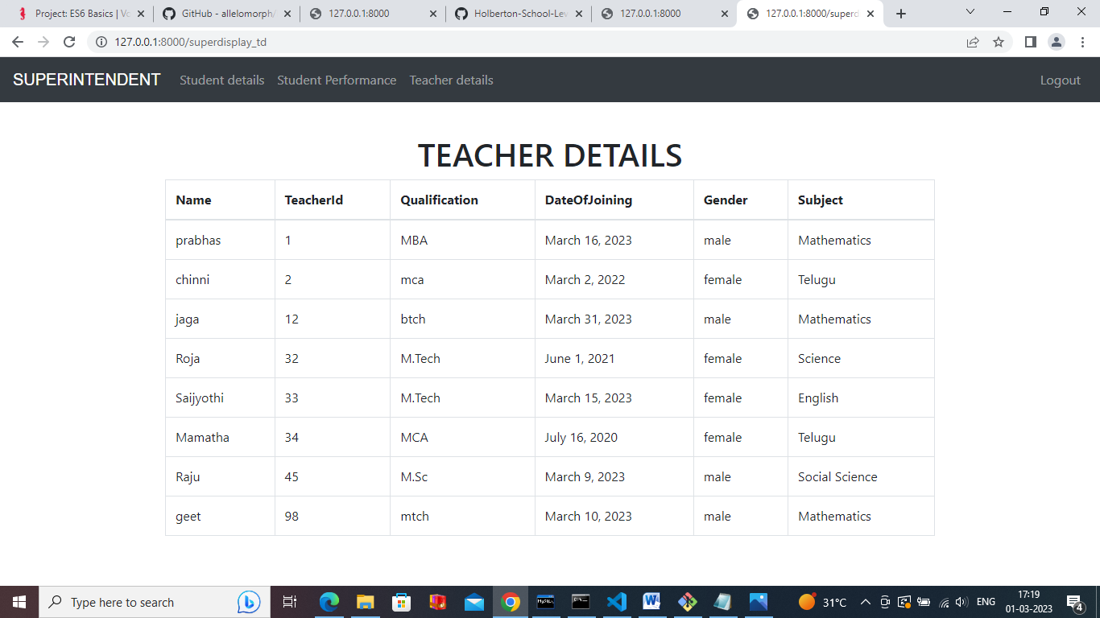

**[Superintendent Login Form]**

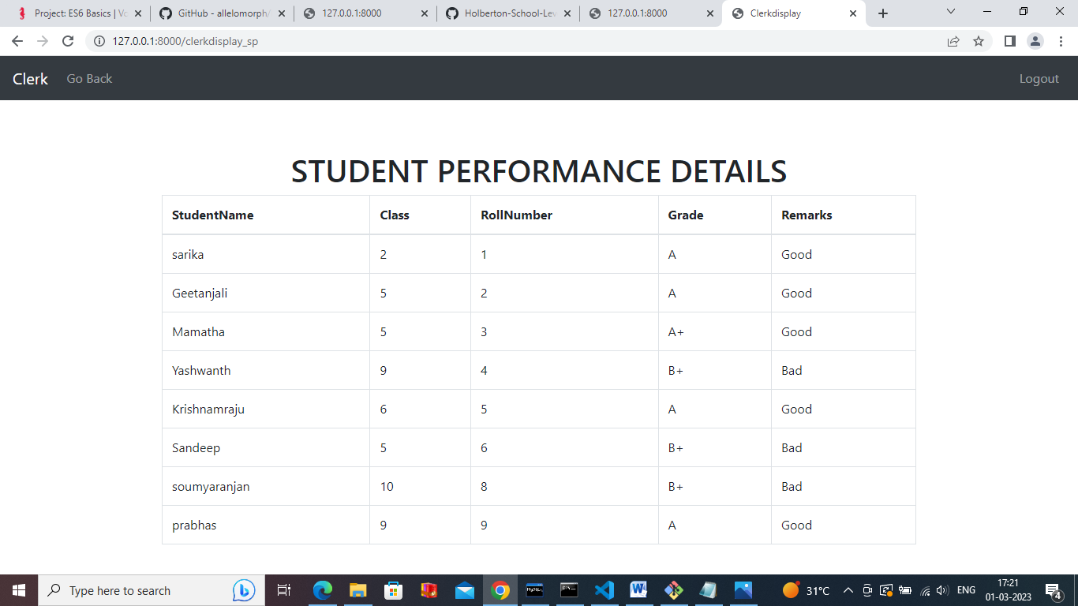

**[Clerk Login Form]**

**MySQL:**

MySQL is an open-source relational database management system (RDBMS) that is widely used for managing and storing data. It was created by Swedish software engineer Michael Widenius in the mid-1990s and is now owned by Oracle Corporation.

MySQL is a popular choice for web-based applications because it can handle large amounts of data and can be used with various programming languages, including PHP, Java, and Python.

It is commonly used for storing data in content management systems (CMS), such as Word Press and Drupal, as well as in e-commerce platforms, such as Magneto and Woo Commerce.

MySQL uses a structured query language (SQL) to interact with databases and supports a wide range of features, including multiple storage engines, transactional processing, and replication. It is also highly customizable and can be tailored to meet the specific needs of individual applications. MySQL is available in both open-source and commercial editions, and it can be downloaded for free from the MySQL website.

**Commands in mysql database:**

* create user ‘root’@’identified by ‘admin’;
* grant all privileges on *.* to ‘root’@’%’ with grant option;
* flush privileges;

**we have to make changes in the schoolproj/setting.py**

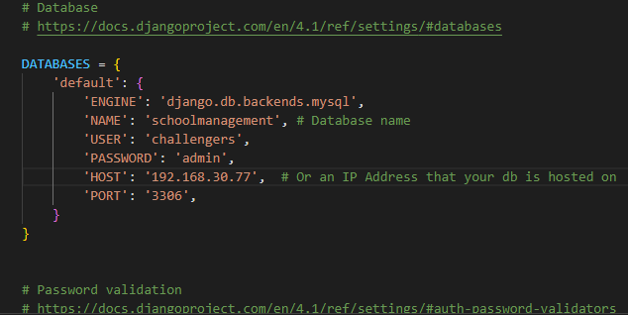

**Bootstrap:**

Bootstrap is the most popular HTML, CSS and JavaScript framework for developing a responsive and mobile friendly website..

Bootstrap is a popular open-source front-end framework used for developing responsive and mobile-first websites and web applications. It was developed by Twitter and was originally released in 2011. The primary purpose of adding it to a web project is to apply Bootstrap's choices of color, size, font and layout to that project. As such, the primary factor is whether the developers in charge find those choices to their liking. Once added to a project, Bootstrap provides basic style definitions Bootstrap is based on HTML, CSS, and JavaScript and provides a set of pre-designed components, such as navigation bars, buttons, forms, and modals that can be easily added to a project to create a user-friendly interface.

Bootstrap also includes a number of CSS classes that can be

Bootstrap also includes a number of CSS classes that can be used to style elements on a page and to implement various design elements, such as typography, colors, and spacing. It allows for quick and easy prototyping, and can be customized to fit the specific needs of a project.

**(Note: In this project we have done page navigations using bootstrap the code as follows: )**

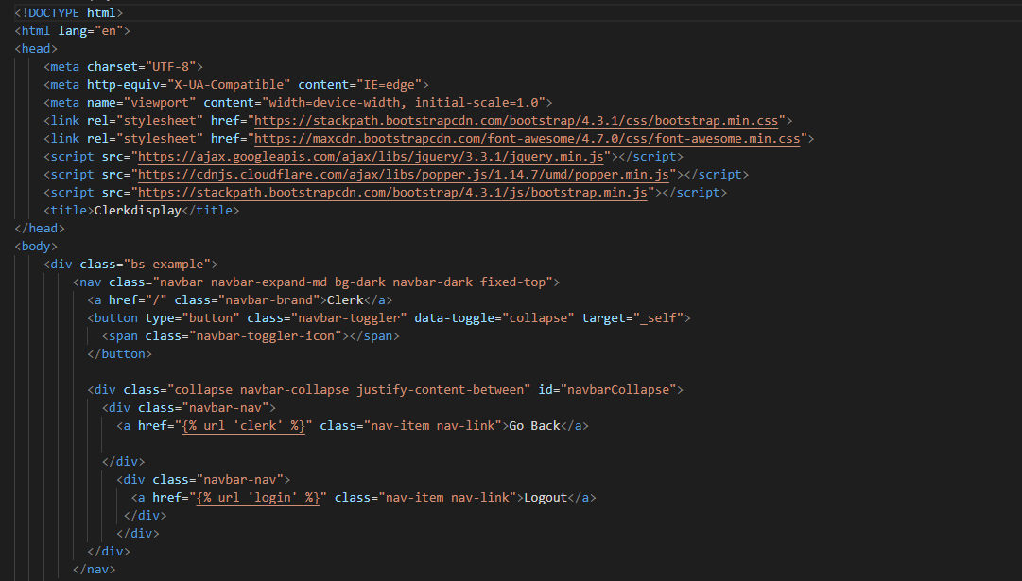

**Python :**

Python is a general purpose high level programming language. Python was developed by Guido Van Rossom in 1989 while working at National Research Institute at Netherlands. But officially Python was made available to public in 1991. The official Date of Birth for Python is Feb 20th 1991. Python is recommended as first programming language for beginners. Python is simple and easy to learn we can use python software without any license and it is freeware. Python is programmer friendly language.

**Django:**

Django is a high-level Python web framework that follows the model-view-template (MVT) architectural pattern. MVT model

M--->model--->to write databases related code

V--->views---> to write business related code

T--->templates--->to write presentation related code it is free and open source and it provides a rich set of tools and libraries for building complex, data-driven web applications. Some of the key features of Django include

Object-relational mapping (ORM): Django includes a powerful ORM that allows developers to interact with databases using Python code, rather than writing SQL queries directly.

URL routing: Django includes a powerful URL routing system that maps incoming requests to the appropriate view function.

Template engine: Django includes a built-in

template engine that allows developers to define

the structure and content of web pages in a flexible and easy-to-read format.

Admin interface: Django includes a built-in admin interface that makes it easy to manage data and content for your application.

Security: Django provides a number of built-in security features, such as protection against SQL injection and cross-site scripting (XSS) attacks.

**Start project** :

**step1: settings.py:**

1. Installapp: 'appname';

2. databases:

DATABASES = {

'default' : {

'ENGINE': 'django.db.backends.mysql'

'NAME': 'schoolmanagement', #Database name

'USER': 'challengers',

'PASSWORD': 'admin',

'HOST':'192.168.30.77',

'PORT':'3306',

}

}

3. import os

4. TEMPLATES = [

DIRS= [os.path.join (BASE_DIR,'templates')]

**step2: MODELS.py**:

A models is python class which is used to create database table. We can use class keyword to create django class. Models. Model is base class for every user defined class. Model is a collection of python class keyword, class name, field name and field type. Use make migrations and migrate commands to convert django model into database table.

**Make migrations**:

**syntax**: -- python manage.py makemigrations.

* We run the make migrations command in terminal then django will go to models.py file and check for latest modifications.
* If any migration are in orm language then it will be converted into Sql language.

Migrate:

**Syntax:** ¬ python manage.py migrate

* It will create a new python file in migrations folder and save the sql code.
* If any python file available in models.py then it will take sql code from that file and execute the database, so it will create table as per django model.

**step 3: Views.py**:

* A views is python function which takes Httprequest and executes the views body and returns HttpResponse.
* We use a def keyword to create views.
* Every view ends with any one of the following function:

**render**: return httpRequest from the templates.

**HttpResponse**:

returns the httpRequest to browser as httpResponse.

4. We use conditional statements to receive the type of request like GET or POST.

• GET:--->GET requests are only used to request data.

• POST:--->POST is stored in the request body of the HTTP request.

• SORT :---> sort is used to descending and ascending by specific column.

**step4: Templates:**

• templates means .html file.

• {{}}--->To write variable name.

• { % %}--->To add link one page to another page

**step5:urls.py:**

It contains all the names and path of views which help to redirect to views.

**step6:** run server syntax: python manage.py run server.

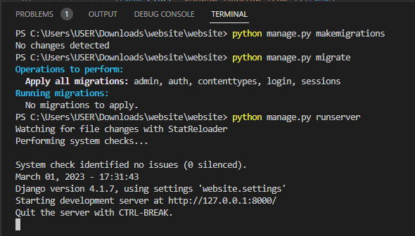

**JavaScript:**

JavaScript is a lightweight, cross-platform, and interpreted compiled programming language which is also known as the scripting language for webpages. It is well-known for the development of web pages , many non-browser environments also use it.

JavaScript can be used for Client-side developments as well as Server-side developments. JavaScript is both imperative and declarative type of language. JavaScript contains a standard library of objects, like Array, Date, and Math, and a core set of language elements like operators, **control structures**, and statements.

**Client-side:** It supplies objects to control a browser and its Document Object Model (DOM). Like if client-side extensions allow an application to place elements on an HTML form and respond to user events such as **mouse clicks**, **form input**, and **page navigation**. Useful libraries for the client-side are AngularJS, ReactJS , and so many others.

**Server-side:** It supplies objects relevant to running JavaScript on a server. Like if the server-side extensions allow an application to communicate with a database, and provide continuity of information from one invocation to another of the application, or perform file manipulations on a server. The useful framework which is the most famous these days is node.js.

.

**CONCLUSION**

School management system is bringing a great difference in the lives of students  and teachers. Good management offers better results  and  more progress towards development.  We have come forward with best-featured school management software to makes it simple and effective to keep track of everything. Digital change is the order of the way in schools. The best school management software update would allow schools to operate more efficiently and more effectively. It helps the school to achieve the target, reduce work, increase efficiency, eliminating error, and monitoring progress.